Exercise 4: Functions

BY: Shubham Sangram Bej

Aim
To create PL/SQL functions for performing common banking operations such as calculating customer age, computing monthly loan instalments, and verifying account balance before transactions.

Scenario 1: Calculate Customer Age

Problem Statement
Calculate the age of customers for eligibility checks. Write a function CalculateAge that takes a customer's date of birth as input and returns their age in years.

Algorithm
- Accept the customer's date of birth.
- Calculate the difference between the current date and the date of birth.
- Convert the difference from months to years.
- Return the calculated age.
- Handle unexpected errors by returning NULL.

Program
CREATE OR REPLACE FUNCTION CALCULATEAGE (
P_DOB DATE
) RETURN NUMBER AS
BEGIN
RETURN FLOOR(MONTHS_BETWEEN(SYSDATE, P_DOB) / 12);
EXCEPTION
WHEN OTHERS THEN
RETURN NULL;
END;
/

SELECT
NAME,
DOB,
CALCULATEAGE(DOB) AS AGE
FROM
CUSTOMERS;

Output

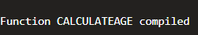
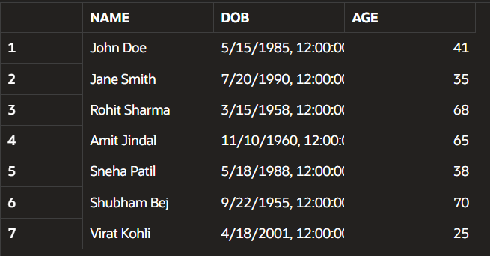

Scenario 2: Calculate Monthly Instalment

Problem Statement

The bank needs to compute the monthly installment for a loan. Write a function CalculateMonthlyInstallment that takes the loan amount, interest rate, and loan duration in years as input and returns the monthly installment amount.

Algorithm
- Accept loan amount, annual interest rate, and duration.
- Convert annual interest into monthly interest.
- Calculate the number of monthly installments.
- Apply the EMI formula.
- Return the calculated installment.
- Handle exceptions appropriately.

Program
CREATE OR REPLACE FUNCTION CALCULATEMONTHLYINSTALLMENT (
P_LOANAMOUNT NUMBER,
P_INTERESTRATE NUMBER,
P_YEARS NUMBER
) RETURN NUMBER AS
V_RATE NUMBER;
V_MONTHS NUMBER;
BEGIN
V_RATE := P_INTERESTRATE / ( 12 * 100 );
V_MONTHS := P_YEARS * 12;
IF V_RATE = 0 THEN
RETURN P_LOANAMOUNT / V_MONTHS;
END IF;
RETURN ( P_LOANAMOUNT * V_RATE ) / ( 1 - POWER(1 + V_RATE, -V_MONTHS) );

EXCEPTION
WHEN OTHERS THEN
RETURN NULL;
END;
/

SELECT
LOANID,
LOANAMOUNT,
INTERESTRATE,
CALCULATEMONTHLYINSTALLMENT(LOANAMOUNT, INTERESTRATE, 5) AS MONTHLYINSTALLMENT
FROM
LOANS;

Output
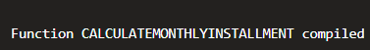

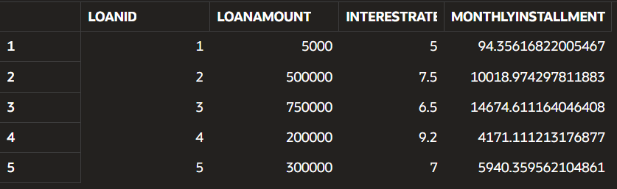

Scenario 3: Check Sufficient Balance

Problem Statement

Check if a customer has sufficient balance before making a transaction. Write a function HasSufficientBalance that takes an account ID and an amount as input and returns a boolean indicating whether the account has at least the specified amount.

Algorithm
- Accept account ID and required amount.
- Retrieve the current account balance.
- Compare the balance with the required amount.
- Return TRUE if sufficient balance exists.
- Return FALSE otherwise.
- Handle invalid account numbers using exception handling.

Program
CREATE OR REPLACE FUNCTION HASSUFFICIENTBALANCE (
P_ACCOUNTID NUMBER,
P_AMOUNT NUMBER
) RETURN BOOLEAN AS
V_BALANCE NUMBER;
BEGIN
SELECT
BALANCE
INTO V_BALANCE
FROM
ACCOUNTS
WHERE
ACCOUNTID = P_ACCOUNTID;

RETURN V_BALANCE >= P_AMOUNT;
EXCEPTION
WHEN NO_DATA_FOUND THEN
RETURN FALSE;
WHEN OTHERS THEN
RETURN FALSE;
END;
/

DECLARE
V_RESULT BOOLEAN;
BEGIN
V_RESULT := HASSUFFICIENTBALANCE(1, 500);
IF V_RESULT THEN
DBMS_OUTPUT.PUT_LINE('Sufficient Balance Available');
ELSE
DBMS_OUTPUT.PUT_LINE('Insufficient Balance');
END IF;

END;
/

Output
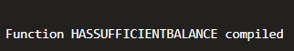

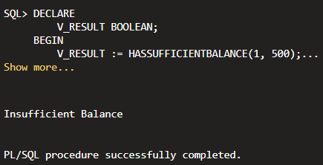

Conclusion
This exercise demonstrated the implementation of PL/SQL functions for reusable banking operations. Functions were developed to calculate customer age, compute monthly loan instalments, and verify account balances before transactions. These functions simplify application logic, improve code reusability, and enhance database efficiency by encapsulating frequently used calculations.

